Understanding and Using
Cervical Traction

Cervical traction is an important part of your chiropractic care. As humans, through improper posture and subluxations we can lose the natural curve of our cervical (neck) spine. This can have serious affects on the body, causing headaches, pain, and tension. Most of all, it puts pressure on your spinal cord, inhibiting your brain-to-body function. Through gentle cervical traction, this process can be stopped, and ultimately reversed.

When using any form of cervical traction, it is important to understand that some level of discomfort is to be expected. Anything new to the body will cause the body to first react to the change that is being introduced. The reaction for most people will be mild as the POSTURE RIGHT neck orthotic only uses the weight of the head and gravity with a specific contact point to achieve the traction.

Most people react to chiropractic, exercise, stretching, and all other forms of body care the SAME way at first, ESPECIALLY IF THE CHANGE IS REALLY NEEDED!

Your chiropractor has recommended this device to make sure you get the maximum value out of your care.

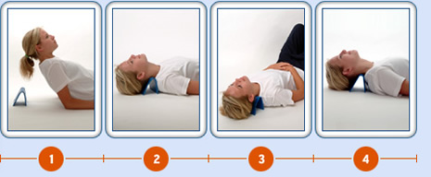

Follow these steps:

- Lie on the floor with your KNEES BENT.
- Place the traction unit under your neck at the vertebra C5. Your chiropractor will have shown you how to locate this specific vertebra. If you find there is too much pressure, place a small towel over the traction device to create a less precise traction point. Make sure you have the neck orthotic positioned properly! The side of the device that says “POSTURE RIGHT” should be facing away from your body. (Slanted angle towards body and perpendicular angle away from body.) To achieve more traction, turn the device around. This should only be done if approved by your chiropractor. IF YOU HAVE ANY QUESTIONS, PLEASE ASK!!!!
- Use daily for best results. The evening is best, when your day is done, and you can relax afterward.
- Start out with 1 – 2 minutes only per session. If you require anything different, your chiropractor will let you know. Eventually, the goal is to get you up to 15 minutes a day.
- Your traction session should work in conjunction with your adjustments and should be done after you receive an adjustment.
- If you are small in frame, or a child using this, place a pillow under the thoracic region of the spine to raise the body to the desired height.

Understand that this is a process, and not an event. Healing and correction takes time. If you have any questions or concerns during the course of your traction treatments, do not hesitate to ask your chiropractor.

Make sure you read the ‘Caution’ notes on the device itself, and discontinue use if any of the noted symptoms arise.

