Stretching safely
Stretching is a key part of your exercise program. Stretching before your workout — especially if you have tight or injured muscles — can prepare your body to exercise. Stretching after your workout promotes better range of motion of your joints. Stretching also improves your flexibility, balance and coordination.
When you're stretching, keep it gentle. Breathe freely as you hold each stretch. Try not to hold your breath. Don't bounce or hold a painful stretch. Expect to feel tension while you're stretching. If you feel pain, you've gone too far.

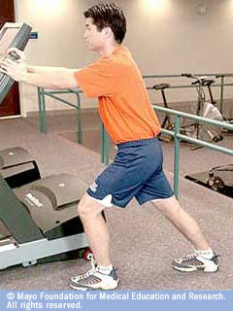 | Calf stretch  Your calf muscle runs along the back of your lower leg.  To stretch your calf muscle, stand at arm's length from a wall or a piece of sturdy exercise equipment. Place your right foot behind your left foot. Keep your right knee straight and your right heel on the floor as you slowly bend your left leg forward. Your back should be straight and your hips forward. Don't rotate your feet inward or outward. Hold the stretch for 30 to 60 seconds. To deepen the stretch, slightly bend your right knee as you bend your left leg forward. Switch legs and repeat.

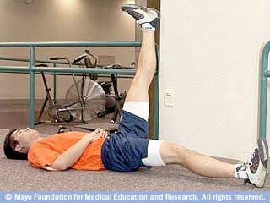 | Hamstring stretch  Your hamstring muscle runs along the back of your upper leg.  To isolate your hamstring muscle without placing stress on your back and neck, lie on the floor near the outer corner of a wall or a door frame. Rest your left heel against the wall, with your left knee slightly bent. Gently straighten your left leg until you feel a stretch along the back of your left thigh. As your flexibility increases, gradually scoot yourself closer to the wall or door frame to maximize the stretch. Hold the stretch for 30 to 60 seconds. Switch legs and repeat.

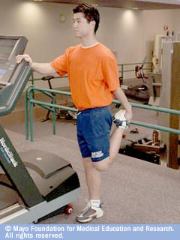 | Quadriceps stretch  Standing near a wall or a piece of sturdy exercise equipment for support, grasp your ankle and gently pull your heel up and back until you feel a stretch in the front of your thigh. This will stretch your quadriceps muscle, which runs along the front of your thigh. Tighten your stomach muscles to prevent your stomach from sagging outward, and keep your knees close together. Hold the stretch for 30 to 60 seconds. Switch legs and repeat.

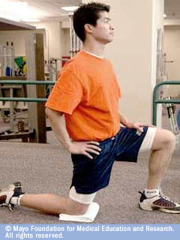 | Hip flexor stretch  Your hip flexor — which allows you to lift your knees and bend at the waist — is located on your upper thigh, just below your hipbone.  To stretch your hip flexor, kneel on your right knee. Cushion your kneecap with a folded towel. Place your left foot in front of you, bending your knee and placing your left hand on your left leg for stability. Place your right hand on your right hip to avoid bending at the waist. Keep your back straight and abdominal muscles tight. Lean forward, shifting more body weight onto your front leg. You'll feel a stretch in your right thigh. Hold the stretch for 30 to 60 seconds. Switch legs and repeat.

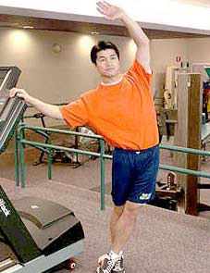 | Iliotibial band (ITB) stretch  The iliotibial band (ITB) is a band of tissue that runs along the outside of your hip, thigh and knee. A tight ITB — a common problem for runners — may cause pain in the outer knee or hip.  To stretch your ITB, stand near a wall or a piece of sturdy exercise equipment for support. Cross your left leg over your right leg at the ankle. Extend your left arm overhead, reaching toward your right side. You'll feel this stretch along your left hip. Hold the stretch for 30 to 60 seconds. Switch sides and repeat.

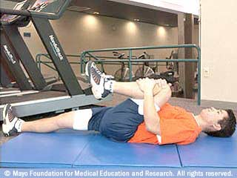 | Knee-to-chest stretch  The knee-to-chest stretch emphasizes the muscles of your lower back.  Lie on your back on a firm surface with your knees and hips bent and the backs of your heels flat on the floor. Gently pull one knee up to your chest until you feel a stretch in your lower back. Keep the opposite leg relaxed in a comfortable position, with your knee bent or with your leg extended as shown. Bring the knee as close to your chest as comfortably possible. Hold the stretch for 30 to 60 seconds. Repeat with the opposite leg.  Avoid the knee-to-chest stretch if you have osteoporosis. You may increase the risk of compression fractures in your vertebrae.
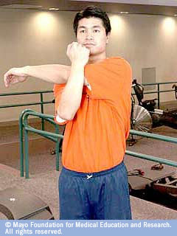 | Shoulder stretch  If the back of your shoulder is tight, you may be more likely to develop rotator cuff problems — especially if you golf or participate in overhead racket or throwing sports, such as tennis or baseball. To keep your shoulder flexible, bring your left arm across your body and hold it with your right arm, either above or below the elbow. Hold the stretch for 30 to 60 seconds. Switch arms and repeat.

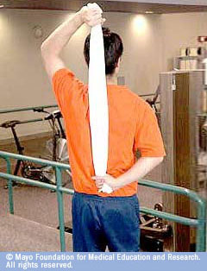 | Shoulder stretch with towel  To stretch your shoulder's internal rotators — part of the group of muscles often used in overhead sports — grasp a rolled-up towel firmly with both hands, as shown. Gently pull the towel toward the ceiling with your top hand. You'll feel a stretch in the shoulder of your opposite arm as your lower hand is gently pulled farther up your back. Hold the stretch for 30 to 60 seconds. Switch hands and repeat.

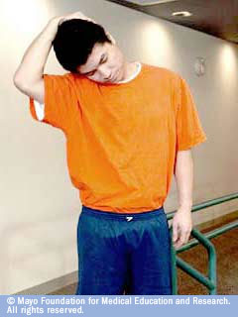 | Neck stretch  To stretch the left side of your neck, bend your head forward and slightly to the right. With your right hand, gently pull your head downward. You'll feel a nice, easy stretch along the back left side of your neck. Don't tug too hard. Remember, you want to hold a comfortable — not painful — stretch. Hold the stretch for 30 to 60 seconds. Repeat on the opposite side.

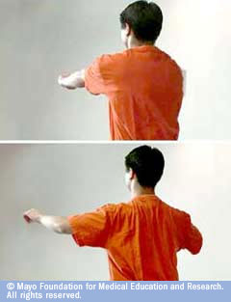 | Chest stretch  Upper back exercises can promote good posture.  Stand in a relaxed position with your arms extended in front of you, parallel to the floor (top). Pull your shoulder blades together behind you, bending your arms slightly at the elbows. You'll notice that your arms spread a little wider as you do this (bottom). Hold the position for a count of five, and then relax as you return to your starting position. Repeat five to 10 times.

